R – Project: “Swedish Motor Insurance Data “

Course: “Data Science with R”

Business Scenario:

Description: Analyse the report of Swedish Motor Insurance

The data gives the details of third-party motor insurance claims in Sweden for the year 1977. In Sweden, all motor insurance companies apply identical risk arguments to classify customers, and thus their portfolios and their claims statistics can be combined. The data were compiled by a Swedish Committee on the Analysis of Risk Premium in Motor Insurance. The Committee was asked to look into the problem of analysing the real influence on the claims of the risk arguments and to compare this structure with the actual tariff.

The insurance dataset holds 7 variables and the description of these variables are given below:

|  |  |
| --- | --- |
| **Variable**  **==========================** | **Description**  **=======================================** |
| Kilo-meters | Kilo-meters travelled per year  1: < 1000  2: 1000-15000  3: 15000-20000  4: 20000-25000  5: > 25000 |
| Zone | Geographical zone  1: Stockholm, Goteborg, and Malmö with surroundings  2: Other large cities with surroundings  3: Smaller cities with surroundings in southern Sweden  4: Rural areas in southern Sweden  5: Smaller cities with surroundings in northern Sweden  6: Rural areas in northern Sweden  7: Gotland |

=================================================================

**Bonus:** No claims bonus; equal to the number of years, plus one, since the last claim

**Make:** 1-8 represents eight different common car models. All other models are combined in class 9.

**Insured:** Number of insured in policy-years

**Claims:** Number of claims

**Payment:** Total value of payments in Skr (Swedish Krona)

----------------------------------------------------------------------------------------------------------------

Expectation /Goals:

After understanding the data, you need to help the committee with the following by the use of the R tool: -

(1) The committee is interested to know each field of the data collected through descriptive analysis to gain basic insights into the data set and to prepare for further analysis

(2) The total value of payment by an insurance company is an important factor to be monitored. So the committee has decided to find whether this payment is related to number of claims and the number of insured policy years. They also want to visualize the results for better understanding.

(3) The committee wants to figure out the reasons for insurance payment increase and decrease. So they have decided to find whether distance, location, bonus, make, and insured amount or claims are affecting the payment or all or some of these are affecting it.

(4) The insurance company is planning to establish a new branch office, so they are interested to find at what location, kilo-meter, and bonus level their insured amount, claims, and payment get increased. (Hint: Aggregate Dataset)

(5) The committee wants to understand what affects their claim rates so as to decide the right premiums for a certain set of situations. Hence, they need to find whether the insured amount, zone, kilo meter, bonus, or make affects the claim rates and to what extent.

`

R-Code File:



R-Code with Output Details and Analysis Details:

#Title: "Swedish Motor Insurance"

#Author: "SANJAY TALLOLLI"

#---------------------------------------------------------------------------

getwd()

setwd("I:\\SIMPLILEARN COURSES LIVE 2018\\DATASCIENCE WITH R\\COURSE MATERIALS\\Project\\Projects for Submission\\Insurance")

# Importing data sets

mydata<-read.csv("I:\\SIMPLILEARN COURSES LIVE 2018\\DATASCIENCE WITH R\\COURSE MATERIALS\\Project\\Projects for Submission\\Insurance\\SwedishMotorInsurance.csv", header = T)

# Goal / Expectation (1):

#The committee is interested to know each field of the data collected through descriptive analysis

#to gain basic insights into the data set and to prepare for further analysis.

summary(mydata)

**#OUTPUT:**

## Kilometres Zone Bonus Make

## Min. :1.000 Min. :1.00 Min. :1.000 Min. :1.000

## 1st Qu.:2.000 1st Qu.:2.00 1st Qu.:2.000 1st Qu.:3.000

## Median :3.000 Median :4.00 Median :4.000 Median :5.000

## Mean :2.986 Mean :3.97 Mean :4.015 Mean :4.992

## 3rd Qu.:4.000 3rd Qu.:6.00 3rd Qu.:6.000 3rd Qu.:7.000

## Max. :5.000 Max. :7.00 Max. :7.000 Max. :9.000

## Insured Claims Payment

## Min. : 0.01 Min. : 0.00 Min. : 0

## 1st Qu.: 21.61 1st Qu.: 1.00 1st Qu.: 2989

## Median : 81.53 Median : 5.00 Median : 27404

## Mean : 1092.20 Mean : 51.87 Mean : 257008

## 3rd Qu.: 389.78 3rd Qu.: 21.00 3rd Qu.: 111954

## Max. :127687.27 Max. :3338.00 Max. :18245026

**#ANALYSIS:**

Brief Statistical Summary all the variables are listed for insight and analysis purpose.

# Goal / Expectation (2):

# The total value of payment by an insurance company is an important factor to be monitored.

#So the committee has decided to find whether this payment is related to number of claims

#and the number of insured policy years.

#They also want to visualize the results for better understanding.

**# Approach (1):**

lm1<-lm(mydata$Payment~mydata$Claims+mydata$Insured)

lm1

**#OUTPUT:**

##

## Call:

## lm(formula = mydata$Payment ~ mydata$Claims + mydata$Insured)

##

## Coefficients:

## (Intercept) mydata$Claims mydata$Insured

## 3250.74 4294.77 28.39

summary(lm1)

**#OUTPUT:**

##

## Call:

## lm(formula = mydata$Payment ~ mydata$Claims + mydata$Insured)

##

## Residuals:

## Min 1Q Median 3Q Max

## -799392 -12743 -3733 10591 861235

##

## Coefficients:

## Estimate Std. Error t value Pr(>|t|)

## (Intercept) 3250.7447 1582.7077 2.054 0.0401 *

## mydata$Claims 4294.7750 18.2819 234.920 <2e-16 ***

## mydata$Insured 28.3881 0.6514 43.580 <2e-16 ***

## ---

## Signif. codes: 0 '***' 0.001 '**' 0.01 '*' 0.05 '.' 0.1 ' ' 1

##

## Residual standard error: 71270 on 2179 degrees of freedom

## Multiple R-squared: 0.9951, Adjusted R-squared: 0.9951

## F-statistic: 2.211e+05 on 2 and 2179 DF, p-value: < 2.2e-16

--------------------------------------------------------------------------------------------------------------

**# Approach (2)**

#with linear we can’t differentiate only tell is it related strongly or not

#p-value of claims and insured is less therefor this means significant role of both for the total payment

cor(mydata$Claims,mydata$Payment)

**#OUTPUT:**

## [1] 0.9954003

**# ANALYSIS:**

#99.54% means positively corelated with payment

cor(mydata$Insured,mydata$Payment)

**#OUTPUT:**

## [1] 0.933217

**# ANALYSIS:**

#93.33% positively corelated insured with payment

#now to plot

plot(mydata$Claims,mydata$Payment)

**#OUTPUT:**

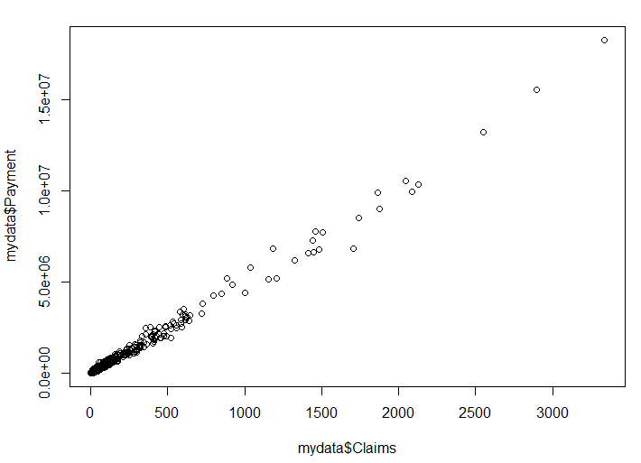

plot(mydata$Insured,mydata$Payment)

**#OUTPUT:**

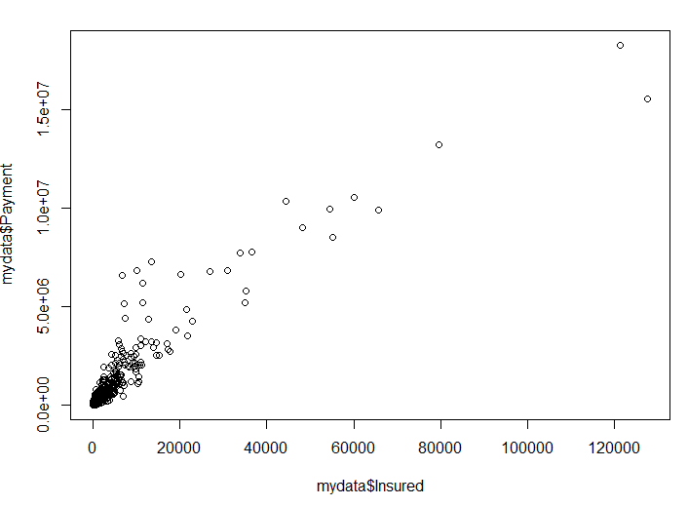

# Goal / Expectation (3):

#The committee wants to figure out the reasons for insurance payment increase and decrease.

#So they have decided to find whether distance, location, bonus, make, and insured amount or

#claims are affecting the payment or all or some of these are affecting it.

#Independent variable: insured, claims, make, bonus, zone, and kilo-meters

# Dependent variable: payment

lm2<-lm(mydata$Payment~.,data=mydata)

summary(lm2)

**#OUTPUT:**

##

## Call:

## lm(formula = mydata$Payment ~ ., data = mydata)

##

## Residuals:

## Min 1Q Median 3Q Max

## -806775 -16943 -6321 11528 847015

##

## Coefficients:

## Estimate Std. Error t value Pr(>|t|)

## (Intercept) -2.173e+04 6.338e+03 -3.429 0.000617 ***

## Kilometres 4.769e+03 1.086e+03 4.392 1.18e-05 ***

## Zone 2.323e+03 7.735e+02 3.003 0.002703 **

## Bonus 1.183e+03 7.737e+02 1.529 0.126462

## Make -7.543e+02 6.107e+02 -1.235 0.216917

## Insured 2.788e+01 6.652e-01 41.913 < 2e-16 ***

## Claims 4.316e+03 1.895e+01 227.793 < 2e-16 ***

## ---

## Signif. codes: 0 '***' 0.001 '**' 0.01 '*' 0.05 '.' 0.1 ' ' 1

##

## Residual standard error: 70830 on 2175 degrees of freedom

## Multiple R-squared: 0.9952, Adjusted R-squared: 0.9952

## F-statistic: 7.462e+04 on 6 and 2175 DF, p-value: < 2.2e-16

**# ANALYSIS:**

# Except bonus and make all are related where km, insured, claims are strongly affecting

# Goal / Expectation (4):

#The insurance company is planning to establish a new branch office, so they are interested

#to find at what location, kilo-meter, and bonus level their insured amount, claims,

#and payment get increased.

grupzone<-apply(mydata[,c(5,6,7)], 2, function(x) tapply(x, mydata$Zone, mean))

grupzone

**#OUTPUT:**

## Insured Claims Payment

## 1 1036.17175 73.568254 338518.95

## 2 1231.48184 67.625397 319921.52

## 3 1362.95870 63.295238 307550.85

## 4 2689.38041 101.311111 537071.76

## 5 384.80188 19.047923 93001.84

## 6 802.68457 32.577778 175528.47

## 7 64.91071 2.108844 9948.19

**# ANALYSIS:**

# Zone 4 has the highest number of claims, and thus payment as well.

# Zones 1-4 have more insured years, claims, and payments.

grupkil<-apply(mydata[,c(5,6,7)],2,function(x)tapply(x,mydata$Kilometres,mean))

grupkil

**#OUTPUT:**

## Insured Claims Payment

## 1 1837.8163 75.59453 361899.35

## 2 1824.0288 89.27664 442523.78

## 3 1081.9714 54.16100 272012.58

## 4 398.9632 20.79493 108213.41

## 5 284.9475 18.04215 93306.12

**# ANALYSIS:**

# Kilo-meter group 2 has the maximum payments. Though the insured number of years is lesser than kilometre 1, the claims and payments are higher for group 2

grupbon<-apply(mydata[,c(5,6,7)],2,function(x)tapply(x,mydata$Bonus,mean))

grupbon

**#OUTPUT:**

## Insured Claims Payment

## 1 525.5502 62.50489 282921.99

## 2 451.0754 34.23397 163316.62

## 3 397.4737 24.97419 122656.17

## 4 360.3867 20.35161 98498.12

## 5 437.3936 22.82109 108790.50

## 6 805.8167 39.94286 197723.82

## 7 4620.3728 157.22222 819322.48

# Goal / Expectation (5):

#The committee wants to understand what affects their claim rates so as to decide the right

#premiums for a certain set of situations. Hence, they need to find whether the insured

#amount, zone, kilo-meter, bonus, or make affects the claim rates and to what extent.

reg<-lm(Claims~Kilometres+Zone+Bonus+Make+Insured,data=mydata)

summary(reg)

**#OUTPUT:**

##

## Call:

## lm(formula = Claims ~ Kilometres + Zone + Bonus + Make + Insured,

## data = mydata)

##

## Residuals:

## Min 1Q Median 3Q Max

## -1214.57 -25.18 -9.41 10.04 1301.78

##

## Coefficients:

## Estimate Std. Error t value Pr(>|t|)

## (Intercept) 37.1230027 7.1270679 5.209 2.08e-07 ***

## Kilometres -3.9648601 1.2255209 -3.235 0.00123 **

## Zone -6.2924300 0.8647405 -7.277 4.75e-13 ***

## Bonus -4.2468101 0.8707236 -4.877 1.15e-06 ***

## Make 6.7725342 0.6755390 10.025 < 2e-16 ***

## Insured 0.0318697 0.0003158 100.933 < 2e-16 ***

## ---

## Signif. codes: 0 '***' 0.001 '**' 0.01 '*' 0.05 '.' 0.1 ' ' 1

##

## Residual standard error: 80.14 on 2176 degrees of freedom

## Multiple R-squared: 0.8425, Adjusted R-squared: 0.8421

## F-statistic: 2328 on 5 and 2176 DF, p-value: < 2.2e-16

**# ANALYSIS:**

#Dependent variable: claims Independent variable: kilometres, zone, bonus, make, and insured

#The result provides the intercept and estimated value and this in turn shows

#that all the p values of independent variables, such as kilometres, zone, bonus, make, and

#insured are highly significant and are making an impact on the claims.

========================== END ===============================